RFID Based exam hall allotting Using Arduino
EE208
COMPUTER ORGANISATION AND MICROCONTROLLERS

This Project report is submitted
By
GNAANESHWAR P S (EE21B1035)
PAKA UDAY (EE21B1037)
PALAMANICKAM(EE21B1038)



DEPARTMENT OF ELECTRICAL AND ELECTRONICS ENGINEERING
NATIONAL INSTITUTE OF TECHNOLOGY PUDUCHERRY
KARAIKAL – 609609
APRIL 2023

INTRODUCTION AND MOTIVATION:
In this project, we have designed RFID Based exam hall allotting using Arduino. EM-18 RFID Reader is a very simple yet effective module. It is an RFID module and is used for scanning RFID cards. It’s a new technology and is expanding day by day. Nowadays it is extensively used in offices where employees are issued an RFID card and their attendance is marked when they touch their card to the RFID reader. We have seen it in many movies that when someone places one’s card over some machine then the door opens or closes. In short, RFID Technology a new emerging technology that is quite useful.

In this project, we have interfaced RFID EM-18 Module with Arduino, RTC Module DS3231, and 20*4 LCD display. RFID Based Attendance System is a wonderful project for final year electronics & electrical students.
LITERATURE SURVEY :
The use of Radio-frequency identification (RFID) technology in automated electronic environment and for tracking objects has been widely researched upon by researchers and deployed by various organizations as part of their automation systems.Zhang Yuru, Chen Delong and Tan Liping ,April, 2013,suggested,The Research and Application of College Student exam hall allotting based on RFID Technology. Combined with the actual situation of college students class attendance system, the design of student attendance system nodes based on RFID has be proposed. In this paper, the hardware node of system and the develop processes of related application have been detailed presentation. The designed system not only can improve the work efficiency, but also can save human and material resources[2].SumitaNainan, Romin Parekh and Tanvi Shah, January 2013,suggested that ―RFID Technology Based Attendance Management System. The proposed framework can give another, precise, and less bulky method for taking understudy participation in school and switch the worldview of understudy's address participation checking in classroom. An ease and cheap RFID Based Authentication System model have effectively created. The model of the framework can give a few advantages over the customary strategy for taking participation. This framework will help in programmed capacity of participation and guardians will be informed in instance of non attendance. In this framework utilizing the AVR controller, guarantees quick operation, cost viability and low power utilization[3].AnkitaAgrawal and AshishBansal, ―Online Attendance Management System Using RFID with Object Counter says that, The Student Attendance System using Radio Frequency Identification technology with object counter will significantly improve the current manual process of student attendance recording and tracking system, especially in a university environment. The system promotes a fully-automated approach in capturing the student attendance and monitoring the student in the university campus. The attendance taken is secure and accurate. The system is user-friendly with easily accessible switches and communication ports. Attendance can be stored and retrieved[4].

BLOCK DIAGRAM:
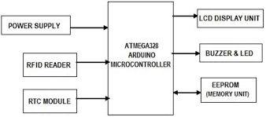

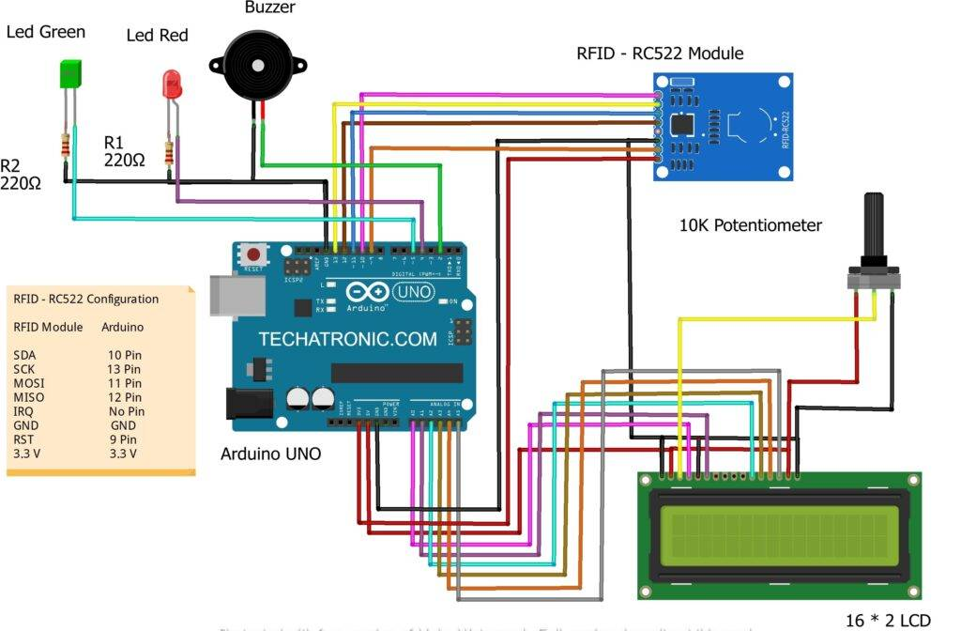

CODE:
#include <SPI.h>
#include <MFRC522.h>
#include "LiquidCrystal.h"
LiquidCrystal lcd(A0, A1, A2, A3, A4, A5);
#define SS_PIN 10
#define RST_PIN 9
#define LED_G 5 //define green LED pin
#define LED_R 4 //define red LED pin
#define BUZZER 2 //buzzer pin
MFRC522 mfrc522(SS_PIN, RST_PIN); // Create MFRC522 instance.
void setup()
{
Serial.begin(9600); // Initiate a serial communication
SPI.begin(); // Initiate SPI bus
mfrc522.PCD_Init(); // Initiate MFRC522
lcd.begin(16,2); // Turn on the blacklight and print a message.
pinMode(LED_G, OUTPUT);
pinMode(LED_R, OUTPUT);
pinMode(BUZZER, OUTPUT);
noTone(BUZZER);
}
void loop()
{
// Look for new cards
if ( ! mfrc522.PICC_IsNewCardPresent())
{
lcd.setCursor(3,0);
lcd.print("SHOW YOUR");
lcd.setCursor(4,1);
lcd.print("ID CARD");
return;
}
else{
lcd.clear();
}
// Select one of the cards
if ( ! mfrc522.PICC_ReadCardSerial())
{
return;
}
//Show UID on serial monitor
Serial.print("UID tag :");
String content= "";
byte letter;
for (byte i = 0; i < mfrc522.uid.size; i++)
{
Serial.print(mfrc522.uid.uidByte[i] < 0x10 ? " 0" : " ");
Serial.print(mfrc522.uid.uidByte[i], HEX);
content.concat(String(mfrc522.uid.uidByte[i] < 0x10 ? " 0" : " "));
content.concat(String(mfrc522.uid.uidByte[i], HEX));
}
Serial.println();
content.toUpperCase();
if (content.substring(1) == "22 AA CF 1E") //change here the UID of the card/cards that you want to give access
{
lcd.print("SEAT:EE21B1038");
delay(1000);
lcd.setCursor(0,1);
lcd.print("ROOM NO:SF-4");
delay(1000);
digitalWrite(LED_G, HIGH);
tone(BUZZER, 500);
delay(300);
noTone(BUZZER);
delay(3000);
digitalWrite(LED_G, LOW);
lcd.clear();
Serial.println("38,sf4");
}
else if (content.substring(1) == "13 4A F8 AC") //change here the UID of the card/cards that you want to give access
{
lcd.print("SEAT:EE21B1037");
delay(1000);
lcd.setCursor(0,1);
lcd.print("ROOM NO:SF-4");
delay(1000);
digitalWrite(LED_G, HIGH);
tone(BUZZER, 500);
delay(300);
noTone(BUZZER);
delay(3000);
digitalWrite(LED_G, LOW);
lcd.clear();
Serial.println("37,sf4");
}
else if (content.substring(1) == "39 FA A2 89") //change here the UID of the card/cards that you want to give access
{
lcd.print("SEAT:EE21B1036");
delay(1000);
lcd.setCursor(0,1);
lcd.print("ROOM NO:SF-5");
delay(1000);
digitalWrite(LED_G, HIGH);
tone(BUZZER, 500);
delay(300);
noTone(BUZZER);
delay(3000);
digitalWrite(LED_G, LOW);
lcd.clear();
Serial.println("36,sf5");
}
else if (content.substring(1) == "83 DA AE 95") //change here the UID of the card/cards that you want to give access
{
lcd.print("SEAT:EE21B1035");
delay(1000);
lcd.setCursor(0,1);
lcd.print("ROOM NO:SF-5");
delay(1000);
digitalWrite(LED_G, HIGH);
tone(BUZZER, 500);
delay(300);
noTone(BUZZER);
delay(3000);
digitalWrite(LED_G, LOW);
lcd.clear();
Serial.println("35,sf5");
}
else {
lcd.print("UNAUTHORIZE");
lcd.setCursor(0,1);
lcd.print("ACCESS");
digitalWrite(LED_R, HIGH);
tone(BUZZER, 300);
delay(2000);
digitalWrite(LED_R, LOW);
noTone(BUZZER);
lcd.clear();
}
}

OBJECTIVES:
Taking attendance manually consumes more time. So, In this project we have designed RFID Based Attendance System using Arduino and RFID MFRC522 Module. In this system, each student is issued an RFID card as their id card and their attendance is marked when they touch their card to RFID reader.
TIMELINE:
 |  | NOV |  | DEC |  |  |  | JAN |  |  |  | FEB |  |  |  | MAR
Week |  | 3 | 4 | 1 | 2 | 3 | 4 | 1 | 2 | 3 | 4 | 1 | 2 | 3 | 4 | 1 | 2 | 3 | 4
Planning for the project idea
Receiving Components understanding it
Interfacing and working on project and finishing the project
 |  |  | Proposed timeline
 |  |  | Actual implementtion

PROPOSED METHODOLOGY:
RFID based attendance system consists of RFID Reader, RFID Tag, LCD display and microcontroller unit. RFID can be interfaced to microcontroller through USART. Data is transferred from RFID cards to reader and from there to microcontroller. Radio frequency technology is used in many applications.

WORKING :
This system works on radio frequency identification. The smart card which you have to put on the reader module is pre-coded with the roll number. Whenever someone uses a card whose information is not registered in the memory the red LED will go on and the buzzer starts beeping. When the system is on it will ask you to show your smart card. For displaying the contents we are using a 16×2 LCD with an I2C module.
Arduino pin diagram:
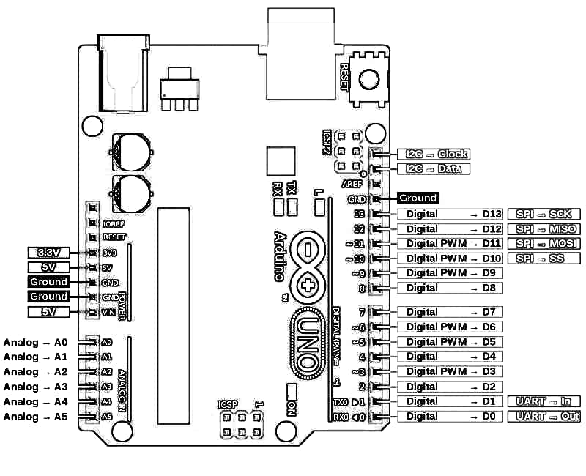
FUTURE WORK:
An RFID-based attendance system makes use of RFID technology to mark student's attendance before every lecture in the institute. The students have to use an RFID tag to mark their presence on the RFID reader. The data is stored in the attendance system with high accuracy and efficiency.
CONCLUSION:
The proposed system can provide a new, accurate, and less cumbrous way of taking student attendance in school and shift the instance of student‘s lecture attendance monitoring in classroom. A low cost RFID Based Attendance System prototype has been successfully developed. The prototype of the system can provide several benefits over the conventional method of taking attendance. This system will help in automatic storage of attendance and parents will be notified in case of absence and it also gives report about their test marks through SMS process. In this system using the ARM7 controller, ensures fast operation, cost effectiveness and low power consumption.
REFERENCES:
1. https://techatronic.com/rfid-based-attendance-system-using-arduino/

